 

**Placement Empowerment Program**

***Cloud Computing and DevOps Centre***

Host a Static Website Locally: Set Up a Local Server Apache and Host a Simple HTML page with your name

Name: Mathimalar.P Department : ADS



**Introduction and Overview**

In this proof of concept (POC), we'll explore how to set up and run a static website on your local machine using the Apache HTTP Server. This involves installing and configuring a local web server and serving a basic HTML page. By the end of this guide, you'll have gained practical experience in configuring Apache and hosting a simple website, which are essential skills for managing web servers and hosting content locally.

**Objective**

The objective of this project is to:

1. Install and configure a local web server using Apache.
2. Set up the server to serve static content.
3. Build and host a basic HTML page that displays your name.

.

Importance of Local Hosting

Local hosting is a crucial skill for developers, enabling them to experiment and test web applications in a secure environment. It provides several benefits, including:

* Practical Experience: Acquire hands-on knowledge of server setup and configuration.
* Testing Environment: Test and debug websites in a controlled space before going live.
* Offline Work: Develop web projects without needing an active internet connection.

**Step-by-Step Overview**

Step1:

Search for "Apache Lounge" on Google and click the first link to access the official website.

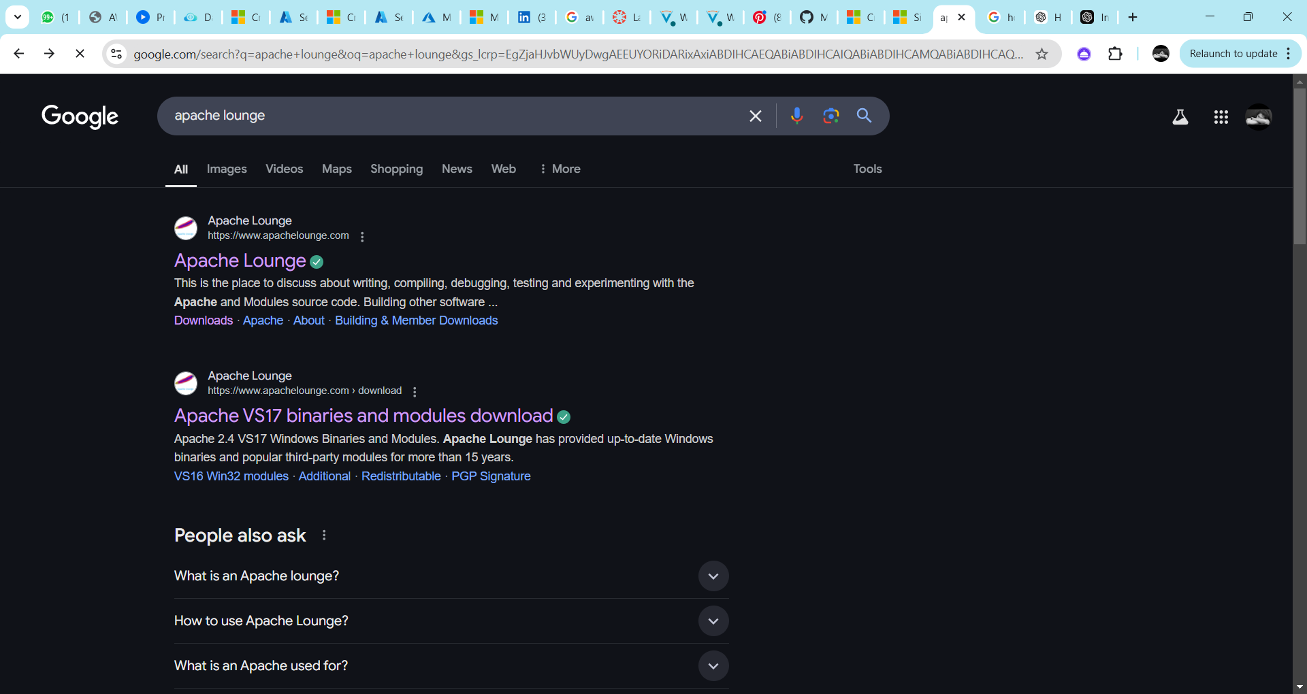

Step 2 :

Click on the "Downloads" option located on the left-hand side of the Apache Lounge website.

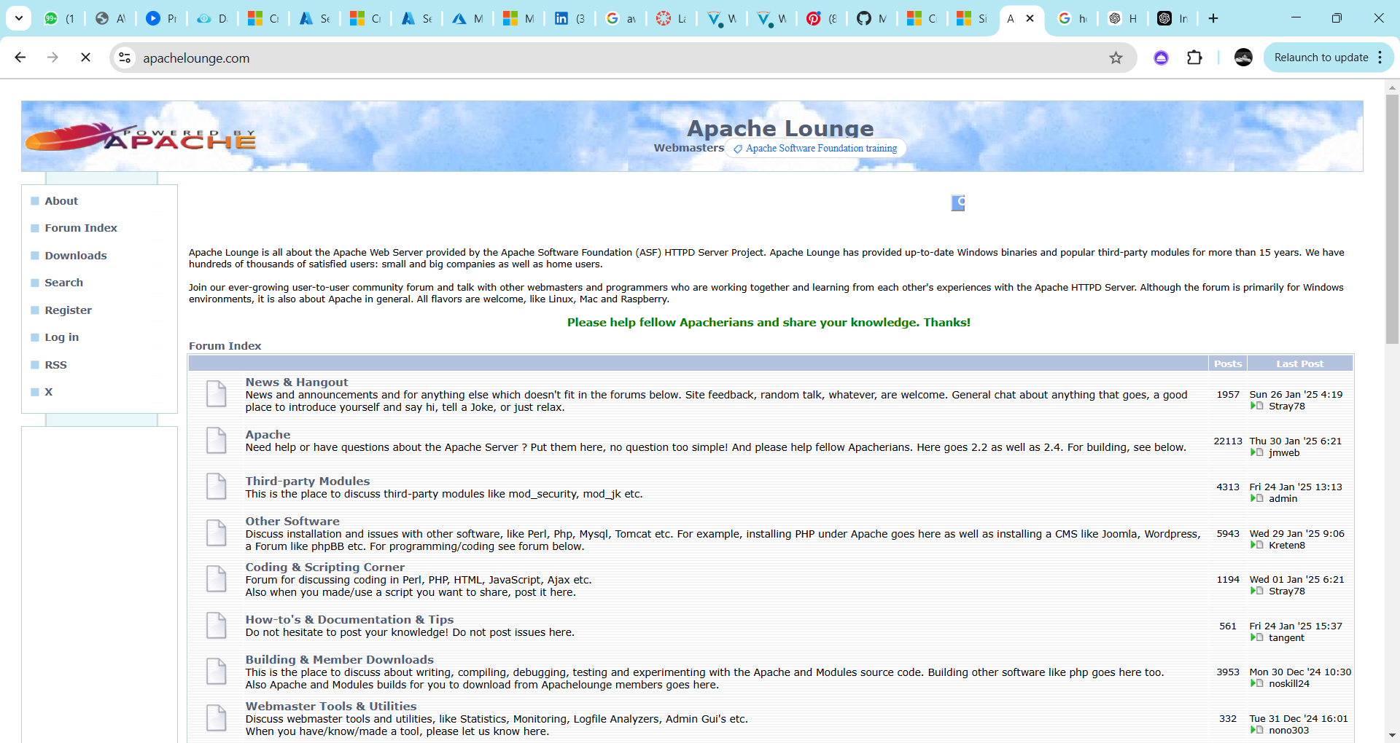

Step 3 :

Click on the link **"Apache 2.4.62-240904 Win64"** (Windows version), download the file, and extract all its contents.

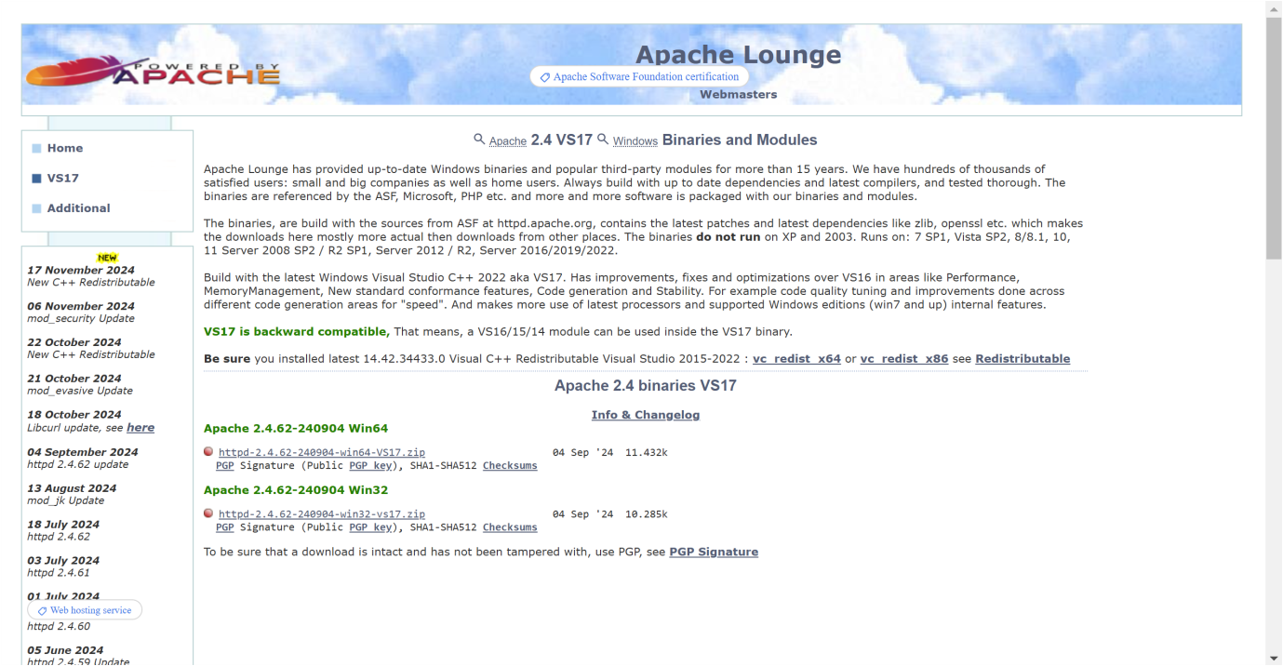

Step 4 :

Open Command Prompt as Administrator (Windows + R, type cmd, right-click and select 'Run as Administrator') and use the command cd C:\path\to\apache\bin to set the path to the Apache bin folder.



Step 5 :

Then Run the installation command :

**httpd.exe -k install**



Step 6 :

Navigate to the Apache folder you downloaded, go to the **conf** folder, and right-click on the httpd.conf file; select 'Edit with Notepad'

(Apache/conf/httpd.conf)

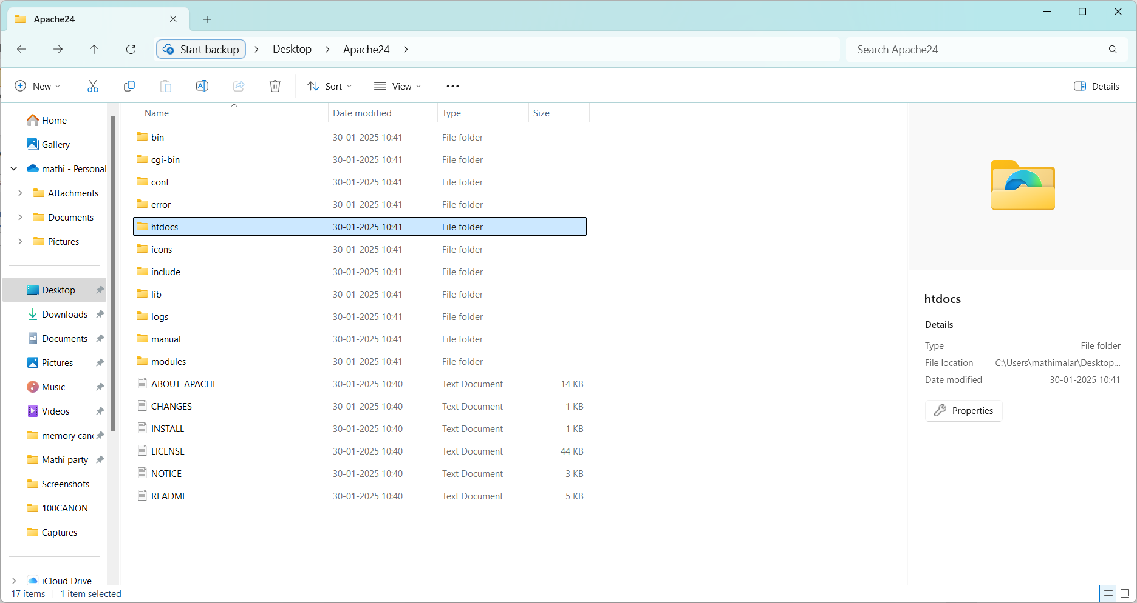

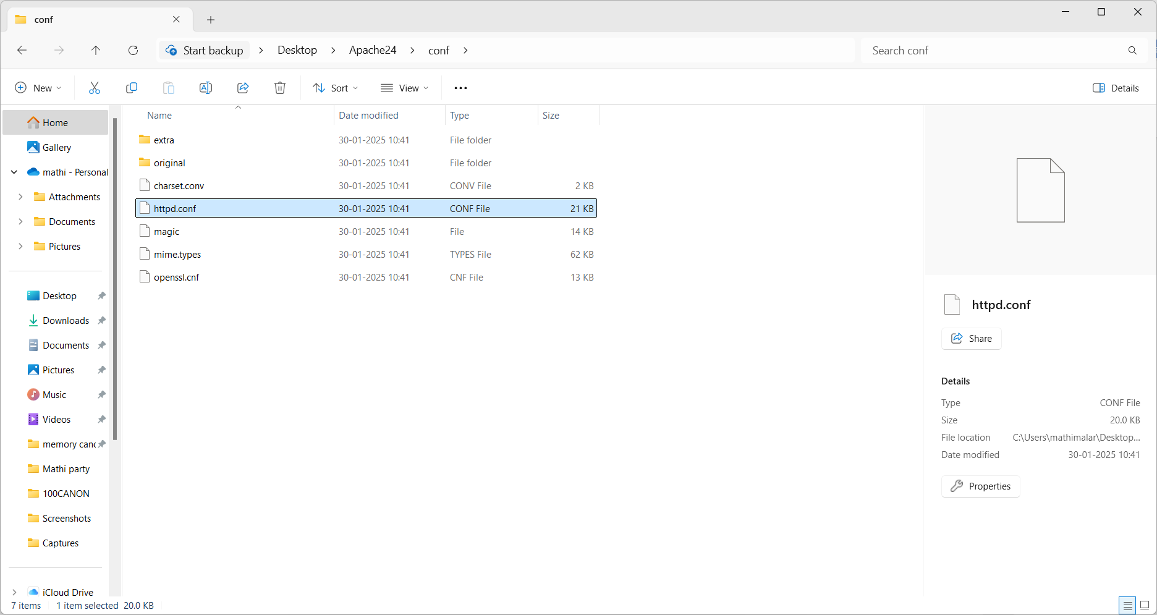

Step 7 :

Inside the **httpd.conf** file, replace the content with the provided configuration. Ensure you update the SRVROOT directive with your Apache installation path. This configuration defines the server’s root directory, listening port, modules, document root for serving web files, logging paths, and basic permissions, ensuring Apache serves content correctly from the specified htdocs directory.

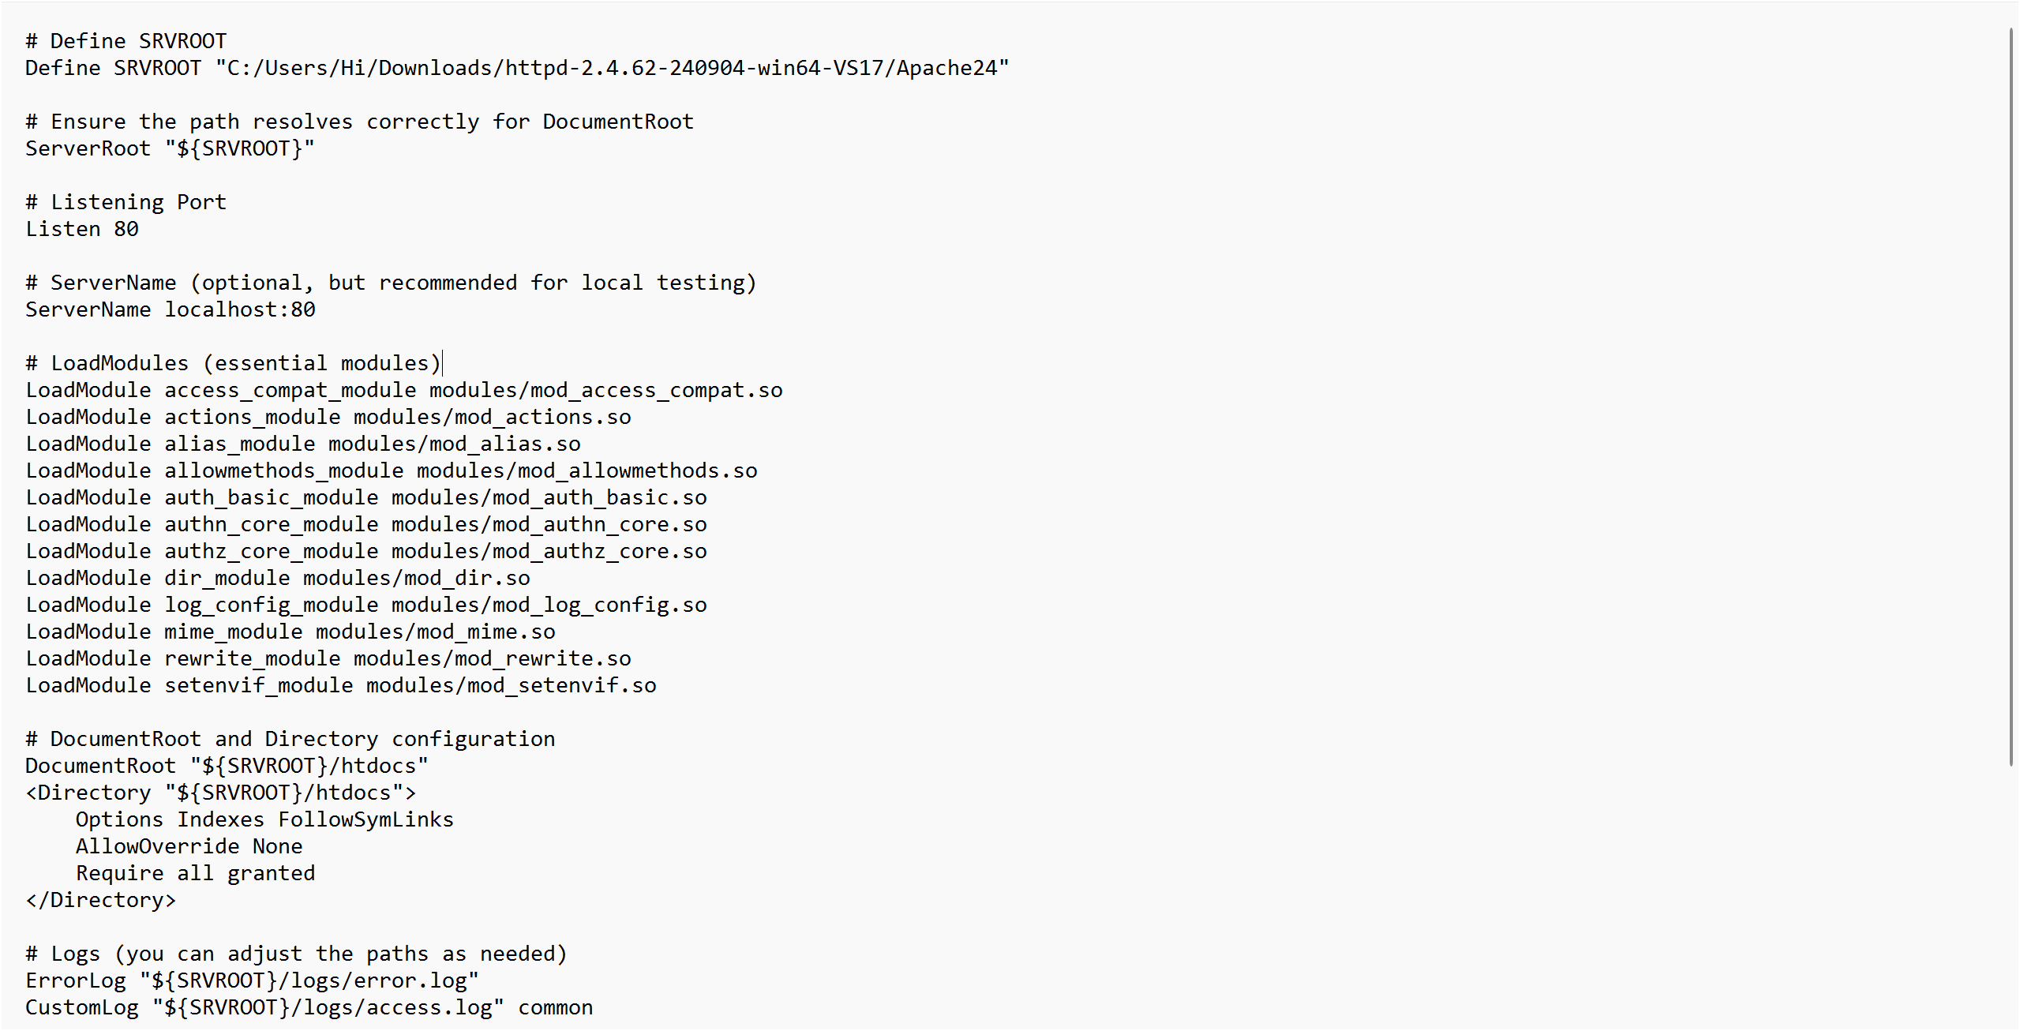

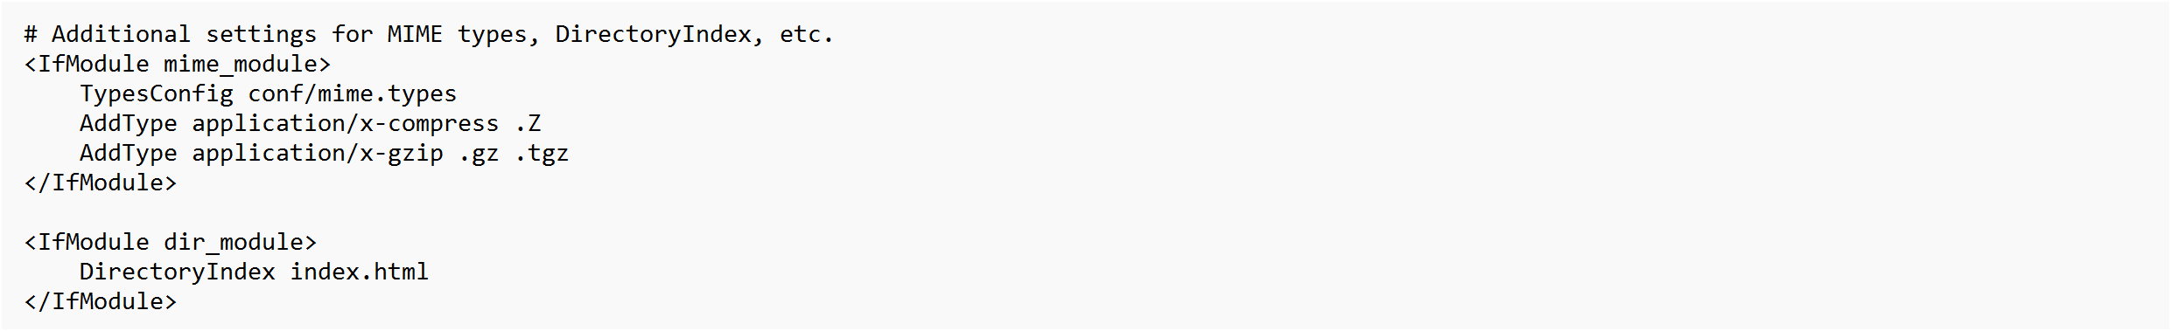

Step 8 :

Open Command Prompt and type the command  **httpd.exe -t** to test the configuration file. If the configuration is correct, you should see **'Syntax OK**'.



Step 9 :

Run the command **httpd.exe -k** start to start the Apache server.



Step10:

Go to the Apache folder, navigate to the **htdocs** folder, and find the **index.html** file. Right-click on it and select 'Edit with Notepad'.



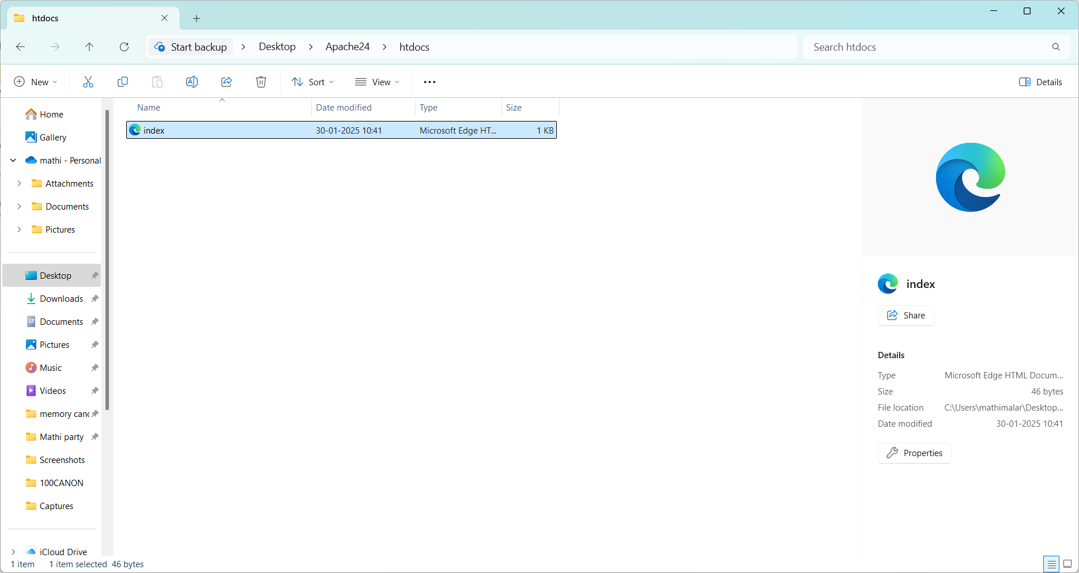

Step 11 :

Create a simple model to display your name in HTML (you may optionally add CSS for styling).

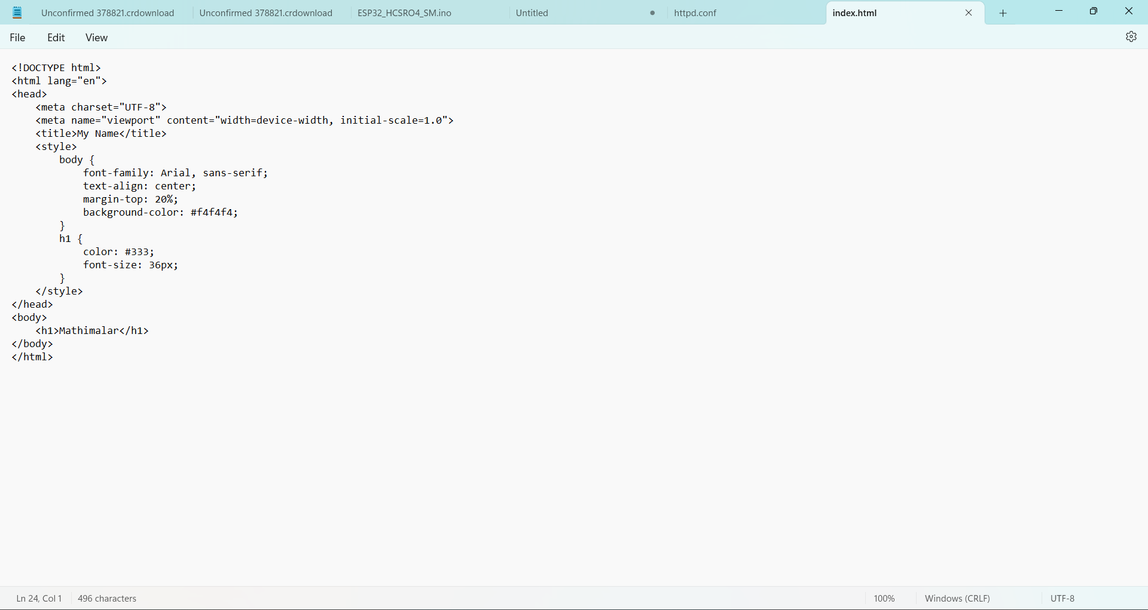

Step 12 :

Open the Chrome browser and type **localhost/index.html** in the address bar. You should be able to see the website hosted successfully.

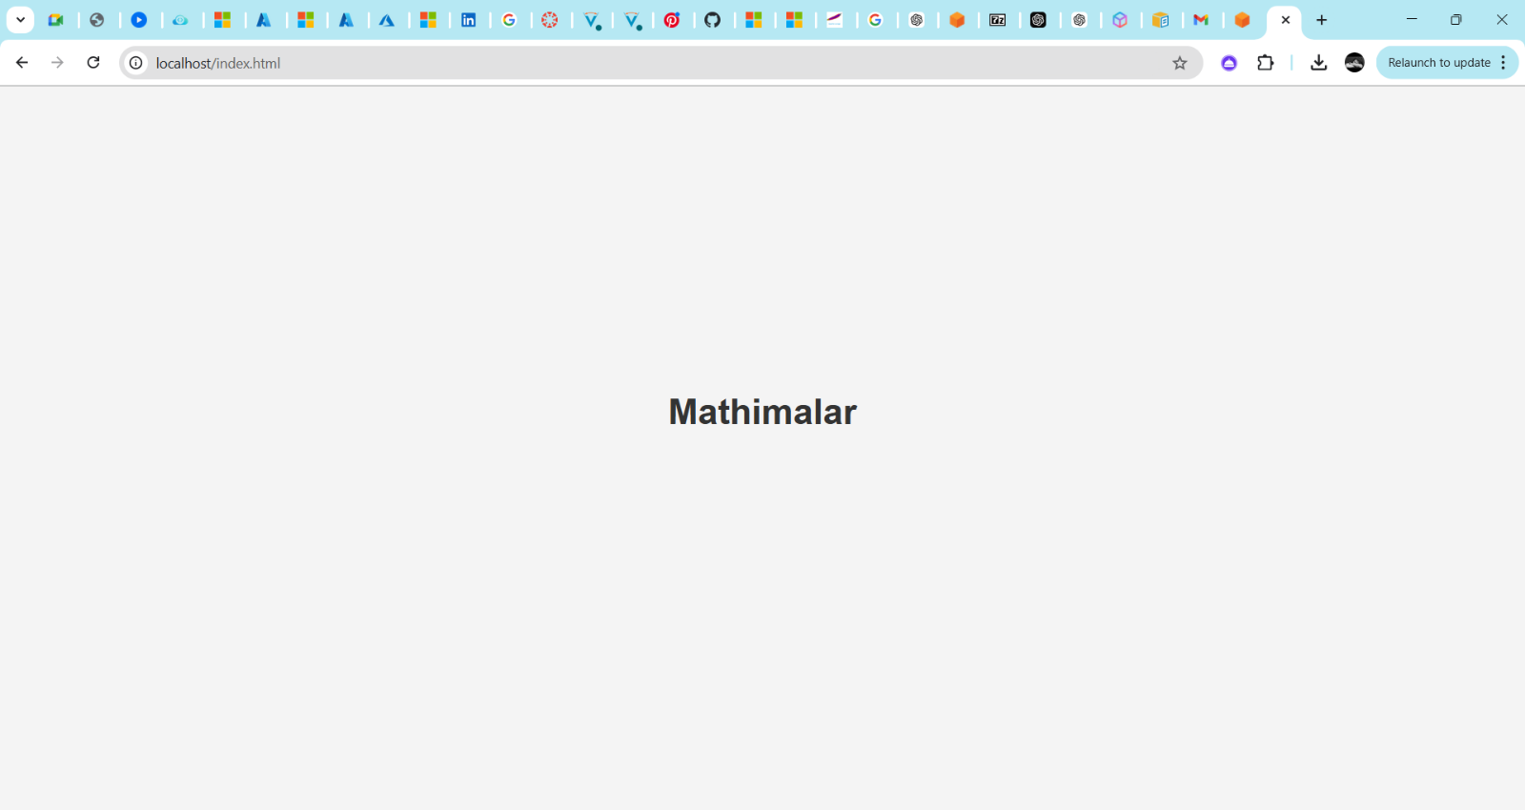

**Expected Outcome**

By completing this POC, you will:

1. Successfully configure and run an Apache server locally.

2. Host a static HTML website that displays your name.

3. Understand the basics of web server configuration and file hosting.